


Project Title

Toycraft Tales: Tableau’s Vision into Toy Manufacturer Data

Team ID: LTVIP2026TMIDS24922
Team Size: 4
Team Leader: Guttikonda Rohith Sai Team member: M. Durga Charan
Team member: Hari Sowgandhi Mummadisetti
Team member: Kolapalli Gnana Pujitha

INTRODUCTION

Project Overview
This project explores the US toy manufacturing industry using Tableau. It focuses on analyzing patterns, trends, and state-wise performance from the years 2005 to 2016.
The dashboard and storyboards help stakeholders derive insights for strategic decisions.

Purpose
To visualize toy manufacturer data to identify trends over time, state contributions, and distribution of manufacturing units using Tableau’s interactive dashboards.

IDEATION PHASE

Problem Statement
Toy manufacturers lack visibility into historical production data and geographic performance, making it difficult to plan future strategies.

Empathy Map Canvas
- Who?: Toy manufacturers, decision-makers, stakeholders

- Think & Feel?: Want clarity, insight into trends
- See?: Fragmented or raw data
- Hear?: Need for dashboards
- Say & Do?: Seek visual insights
- Pain?: No centralized visibility
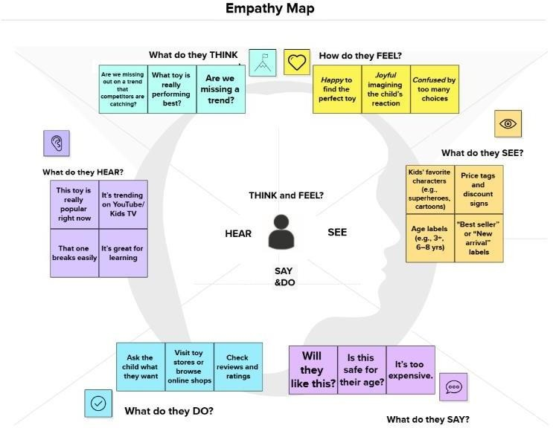
- Gain?: One-stop analytical dashboard

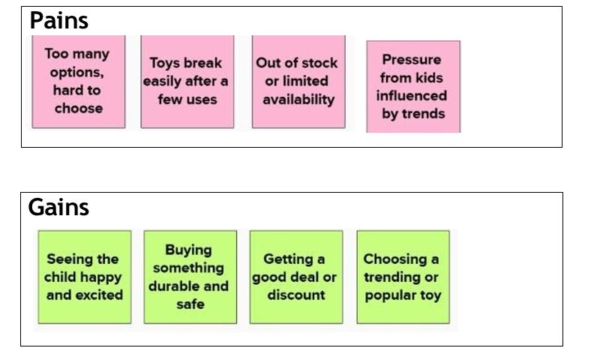

Brainstorming
- Use Tableau for interactive visuals
- Analyze time-based decline/growth
- Use maps and pie charts for geographic spread
- Show high/low performing states
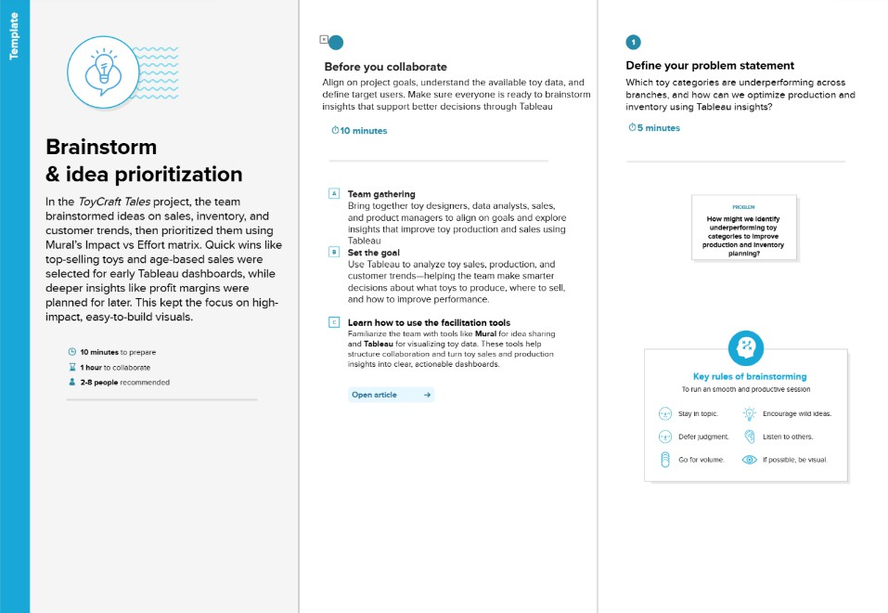

REQUIREMENT ANALYSIS

Customer Journey Map

Stage | Actions | Emotions | Pain Points
Data Access | Load CSVs into Tableau | Curious | Raw data not easily readable
Visualization | Create charts, dashboards | Confident | Layout alignment issues
Insights | Story creation, analysis sharing | Informed | Limited export options
  - Solution Requirement

FR  No. | Functional Requirement (Epic) | Sub Requirement (Story / Sub-Task)
FR-1 | User Registration | - Registration through Form  - Registration through Gmail
FR-2 | User Login | - Login with Email and Password
FR-3 | Profile Management | - create/update Client profile  - create/update freelancer Profile(including skills and portfolio)
FR-4 | Project Management(client) | - Post new project and view bids on project  - select freelancer for project  - review submitted work  - Provide feedback/Rating for freelancer.
FR-5 | Project management(Freelancer) | - Browser/Filter projects  - submit Bids on projects  - submit completed project work.
FR-6 | Communication&collaboration | - Integrated Chat System for Client-Freelancer Communication  - Real-time Updates and Notifications
FR-7 | Admin Panel | - Manage Users(clients and freelancers)  - Manage Projects/transactions

  - Data Flow Diagram
CSV File → Tableau Data Pane → Visual Charts → Dashboard → Insights
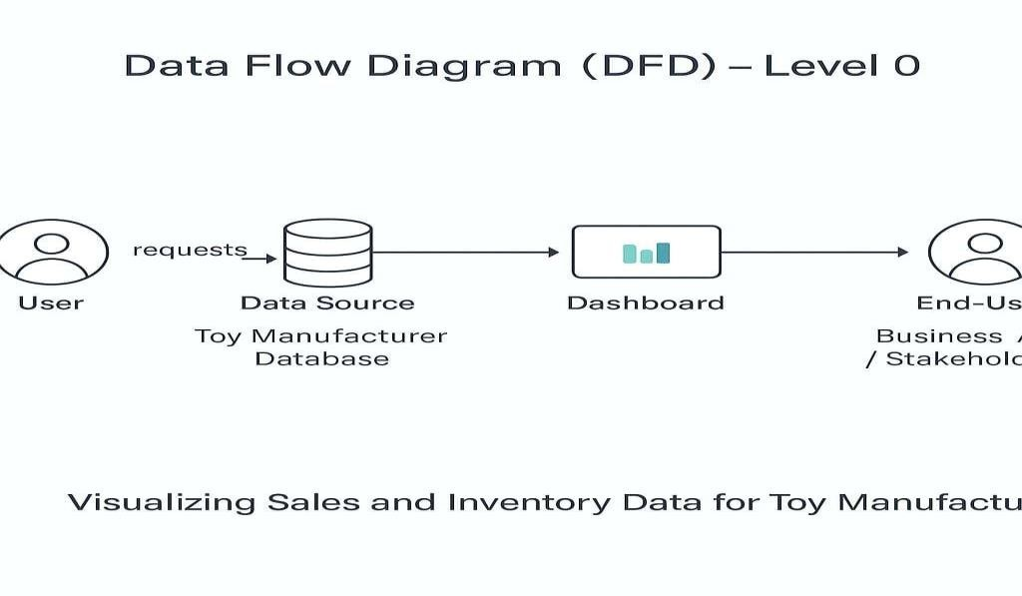

  - Technology Stack
- Tool: Tableau
- Language: Drag-and-drop interface, no code
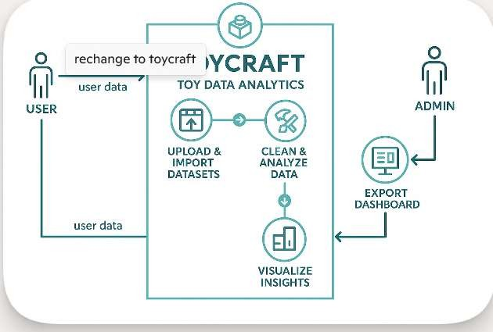
- Data: CSV - Week 39: US Toy Manufacturers (2005–2016)

PROJECT DESIGN

Problem Solution Fit
The project fits by transforming raw manufacturer data into valuable visual narratives using Tableau's interactive capabilities.
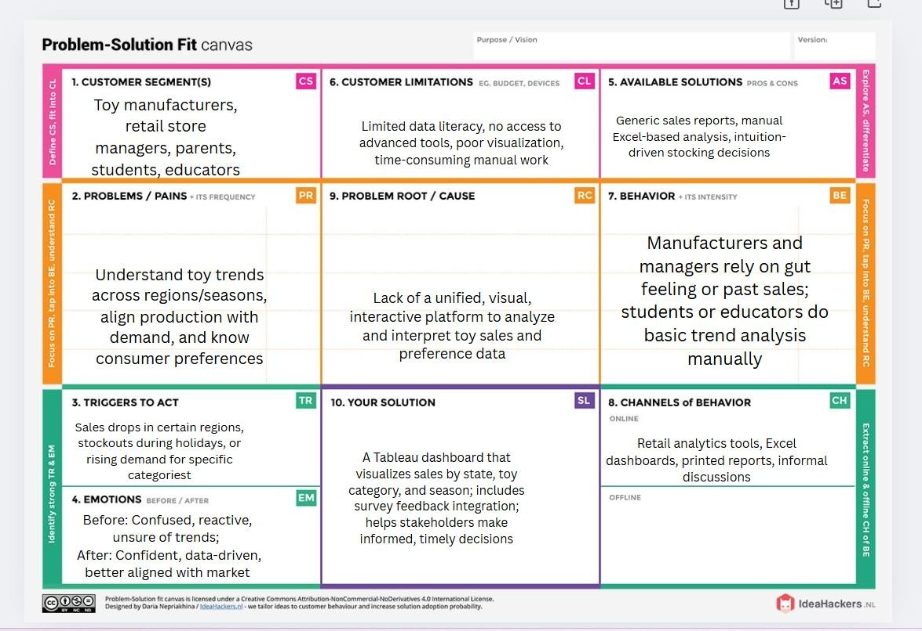

Proposed Solution
An interactive Tableau dashboard and story board to showcase manufacturer trends, top-performing states, and manufacturer counts.
S.No. | Parameter | Description
1. | Problem Statement (Problem to be solved) | Toy manufacturers and stakeholders lack clear insights into toy sales trends, consumer preferences, and regional demand, making it difficult to optimize inventory, marketing, and  production strategies.
2. | Idea / Solution description | The project provides a Tableau-based interactive dashboard that visualizes toy manufacturing data, showing seasonal sales trends, regional preferences, and consumer feedback collected through surveys. It helps  users make data-driven decisions.
3. | Novelty / Uniqueness | Combines real-time survey feedback with historical manufacturing data; user-friendly filters and visuals allow even non-technical users to analyze toy trends across states,  seasons, and categories.
4. | Social Impact / Customer Satisfaction | Helps parents, educators, and retailers understand and choose suitable toys. Enhances customer satisfaction by aligning toy offerings with actual preferences and promoting  informed purchases.
5. | Business Model (Revenue Model) | Potential monetization through freemium access: free insights for users, and premium access for manufacturers or retailers seeking advanced filters, forecasting, or regional  breakdowns.
6. | Scalability of the Solution | Easily scalable by adding more data (e.g., multi- year sales), new toy categories, additional  regions, or advanced predictive features like trend forecasting and personalization.

Solution Architecture
- Input: Dataset (CSV)
- Process: Import → Clean → Visualize
- Output: Dashboards + Storytelling
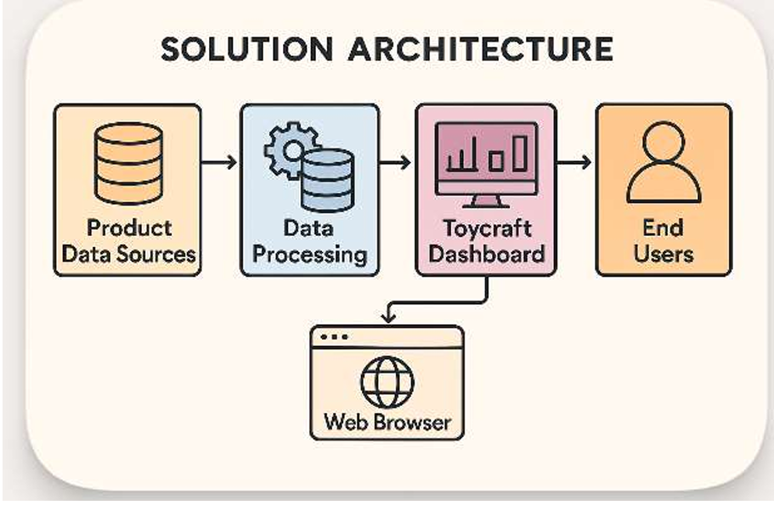

5.PROJECT PLANNING & SCHEDULING

5.1Project Planning

Phase | Timeline | Tools Used
Data Collection | Day 1 | CSV, Excel
Visualization | Days 2–3 | Tableau
Dashboard Design | Day 4 | Tableau
Story Creation | Day 5 | Tableau

Sprint | Total Story Points | Duration | Sprint Start Date | Sprint End Date (Planned) | Story Points Completed (as on Planned End Date) | Sprint Release Date (Actual)
Sprint- 1 | 11 | 3 days | 29 Jan 2026 | 31 Jan 2026 | 11 | 31 Jan 2026
Sprint- 2 | 10 | 3 days | 01 Feb 2026 | 03 Feb 2026 | 10 | 03 Feb 2026
Sprint- 3 | 07 | 3 days | 04 Feb 2026 | 06 Feb 2026 | 07 | 06 Feb 2026
Sprint- 4 | 07 | 3 days | 07 Feb 2026 | 09 Feb 2026 | 07 | - Feb 2026

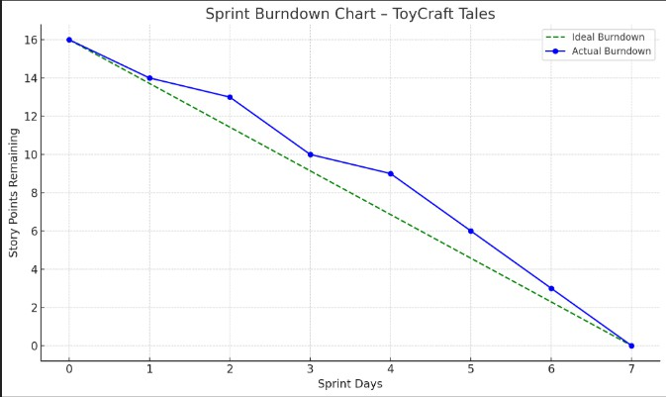

6.FUNCTIONAL AND PERFORMANCE TESTING

Performance Testing
- Dashboard Loading Time: Less than 2 seconds

S.No | Parameter | Screenshot / Values
1. | Data Rendered | Dawt,index,State,Year,Number of Manufacturers
2. | Data Preprocessing | Cleaned columns, formatted values
3 | Utilization of Filters | Index,State,Year,Number of Manufacturers
4 | Calculated Fields Used | Index,State,Year,Number of Manufacturers,DAWT.csv
5 | Dashboard Design | No. of Visualizations / Graphs - 5
6 | Story Design | No. of Visualizations / Graphs - 5

7. RESULTS

7.1Number of Manufacturers Over Time
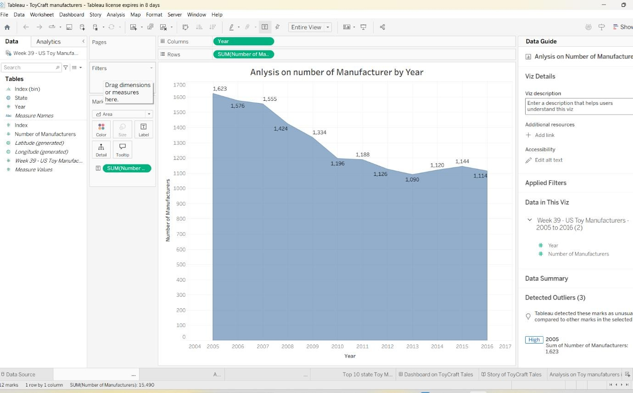
Chart showing decline in manufacturers from 2005 to 201

Index Distribution of Manufacturers
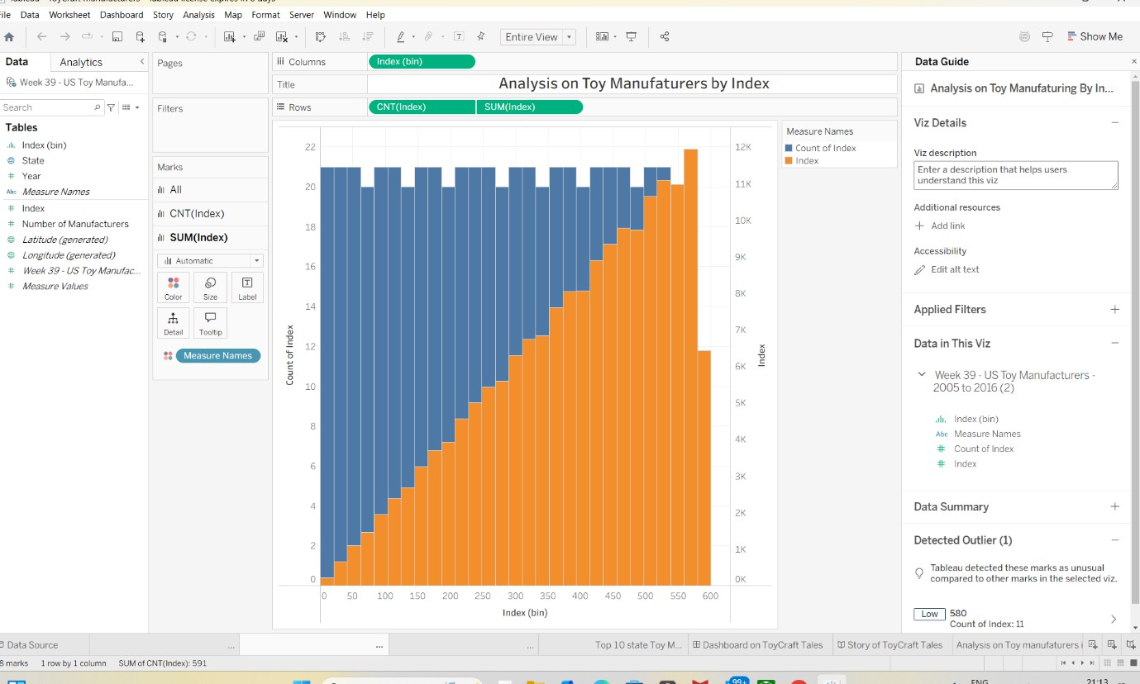
Bar chart showing count and sum of index

Measure Comparison Chart
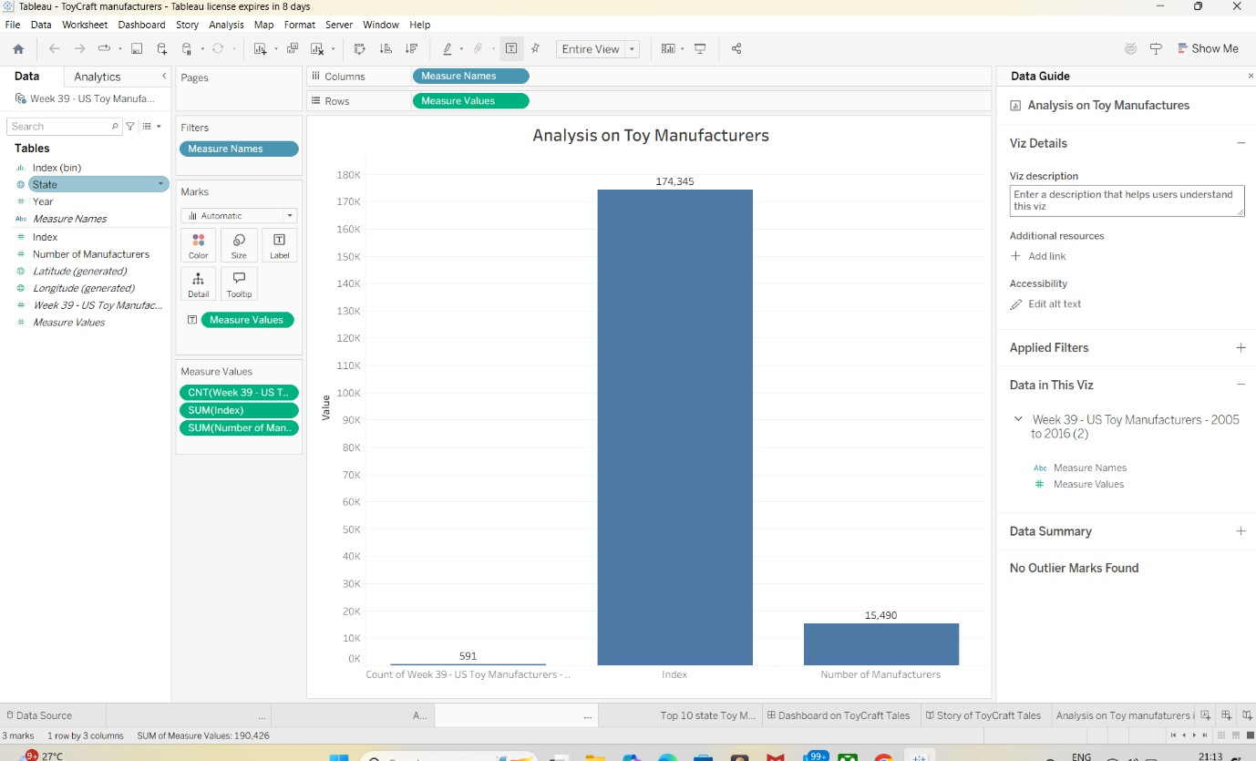
Vertical bars for index and manufacturer count

Top 10 States by Manufacturer Count
Horizontal bar chart
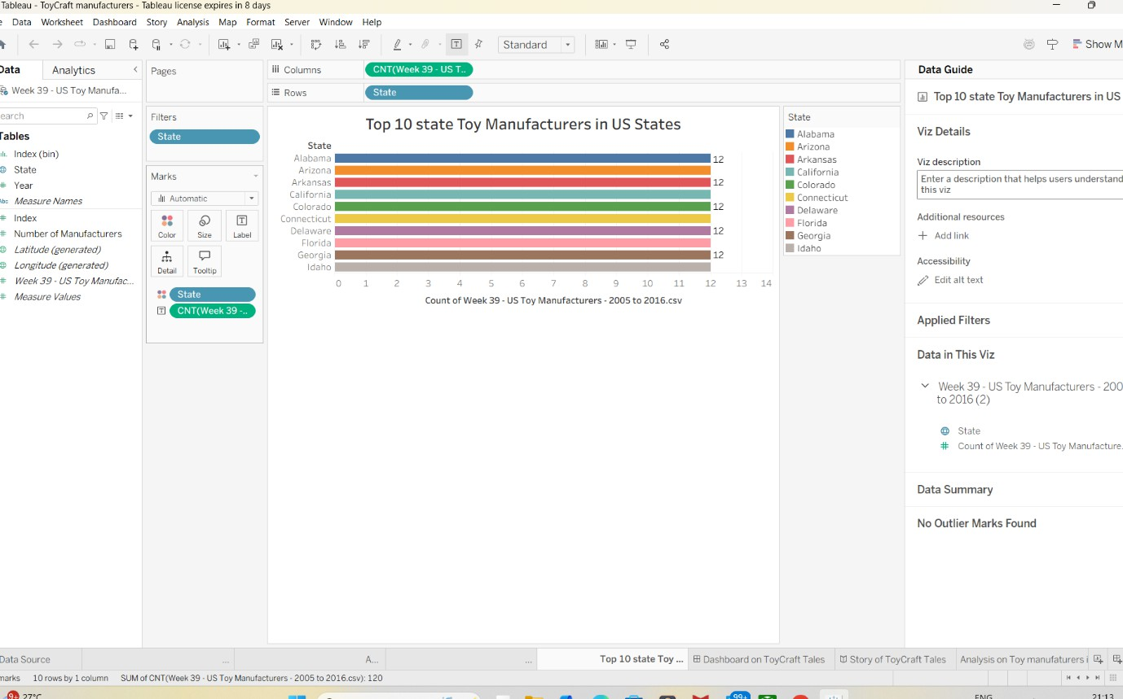

Pie Chart – Index by States
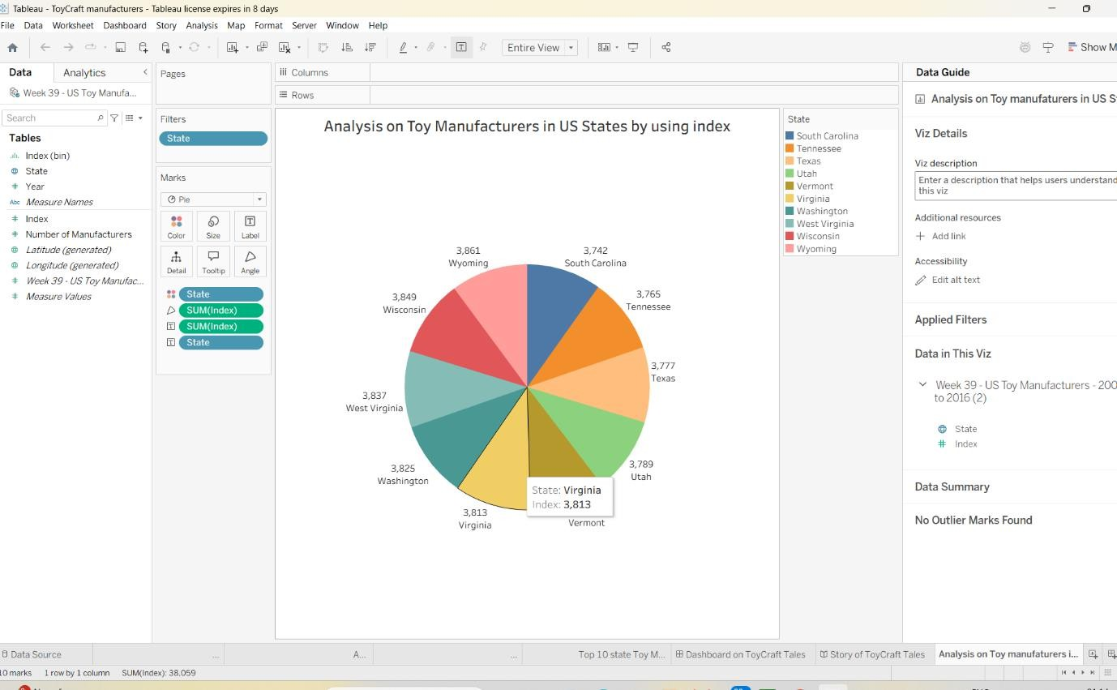
Pie chart distribution of index

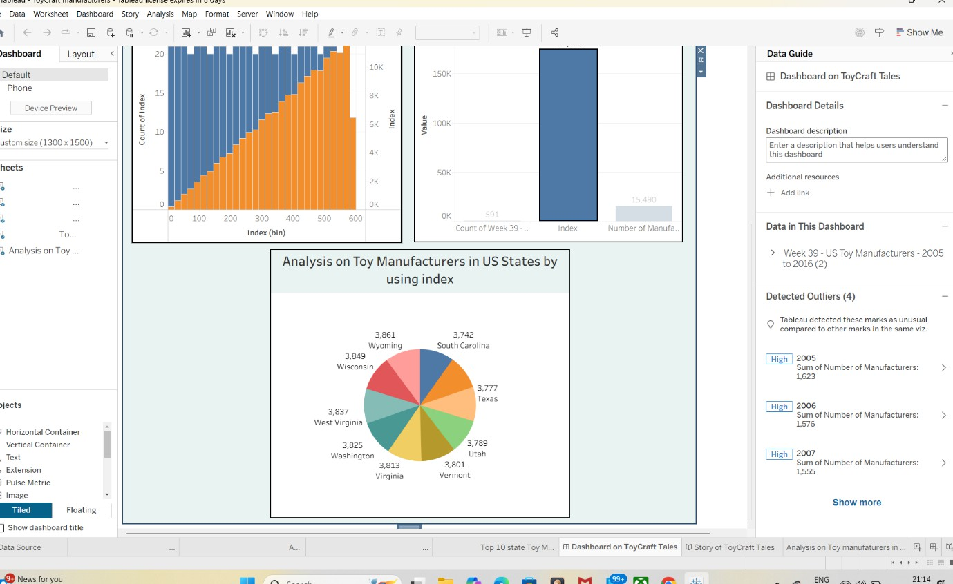
Final Dashboard View
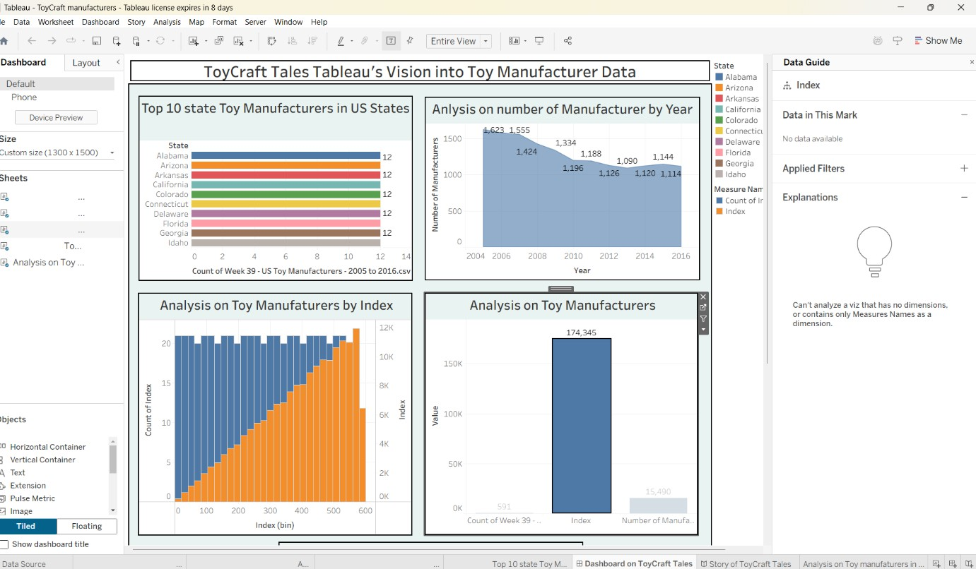
Full Tableau dashboard

Storyboard View
Story point with navigation tabs
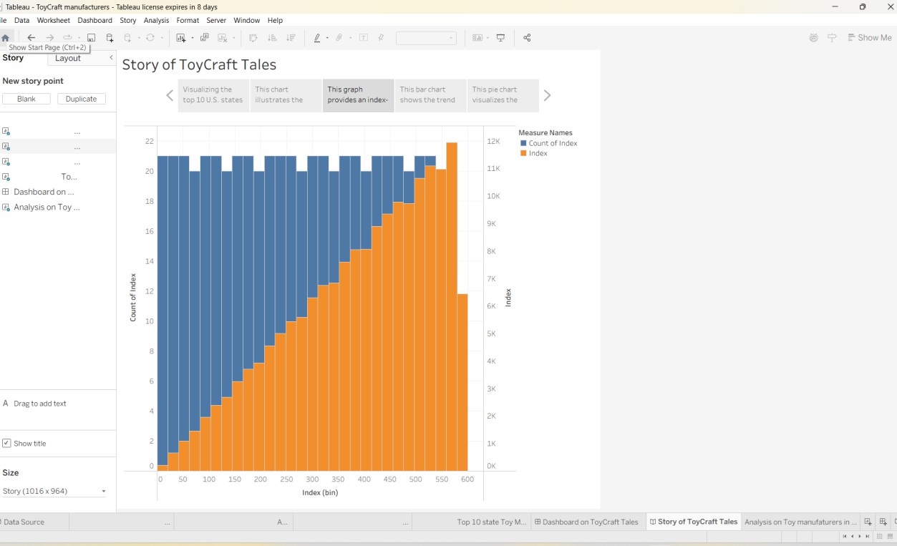

ADVANTAGES & DISADVANTAGES

Advantages
- Interactive and dynamic visuals
- Fast insights without programming
- Clear trend and state-wise distribution

Disadvantages
- Limited customization outside Tableau
- Desktop version has licensing limits
- No predictive analytics

CONCLUSION
The Tableau-based visualization system successfully uncovers historical trends in toy manufacturing, enabling better strategic planning and stakeholder insights.

FUTURE SCOPE
- Integration with live data sources
- Predictive analytics using Python/ML
- Mobile responsive dashboards
- Export functionality for reports

APPENDIX

Source Code
No programming used – Tableau visual interface

Dataset Link
Dataset: Week 39 – US Toy Manufacturers (2005–2016)

